

**COMPUTER NETWORKS LAB**

**LAB 1**

**Submitted by:**

Maryam Masood

**Roll No. :** SU92-BSSEM-F22-197

**Section:** BSSE-2D

**Date:** 21/09/2024

**Submitted to:**

Sir Rasikh Ali

**Lab 1 - Tasks**

**Task 1:**

What is the difference between all the routers, and when to use them (mentioned in cisco packet tracer).

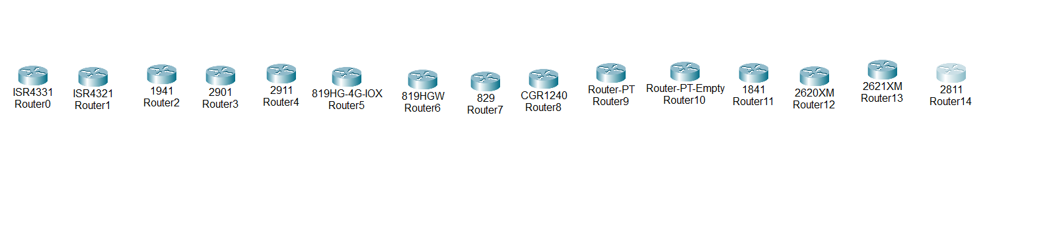

1. **ISR4331 (Router0)** and **ISR4321 (Router1)**
   * **ISR (Integrated Services Routers)**: Routers in the ISR series are enterprise-grade and used in medium to large-scale businesses. They offer security, voice, and WAN capabilities.
   * **Use**: For advanced routing tasks, where you need built-in security features, modular designs, and multiple services like VPN, firewall, or voice services.
2. **1941 (Router2)**
   * **Cisco 1941 Router**: This is from the **Cisco 1900 series**, designed for small to medium-sized businesses. It provides modularity and WAN, security, and application services.
   * **Use**: Best for smaller setups that still need features like modular WAN and security without the overhead of the ISR models.
3. **2901 (Router3)** and **2911 (Router4)**
   * These routers belong to the **Cisco 2900 series** and are often used in branch offices or small to medium-sized enterprises.
   * **Use**: When you need more processing power and modular expansion than the 1900 series but don’t require the full capabilities of higher-end ISRs.
4. **819HG-4G-IOX (Router5)** and **819HGW (Router6)**
   * These routers are **Cisco 819 ISR models**, designed for M2M (Machine-to-Machine) communications and IoT (Internet of Things) applications. They often have 4G LTE support and are compact.
   * **Use**: Ideal for remote locations where you need cellular (4G/5G) connectivity, IoT device management, or rugged environments.
5. **829 (Router7)**
   * This model is part of the **Cisco 800 series** and is also suitable for mobile applications, often featuring LTE connectivity.
   * **Use**: For mobile environments or scenarios where you need WAN capabilities on the go, such as in vehicles or remote offices.
6. **CGR1240 (Router8)**
   * **Cisco Connected Grid Router**: These are specialized routers for smart grid applications in utilities like electricity distribution.
   * **Use**: Designed for utility companies for critical infrastructure and environments requiring high reliability in outdoor or harsh conditions.
7. **Router-PT (Router9)**
   * **Router-PT**: A generic router model in Packet Tracer without specific hardware limitations.
   * **Use**: For basic network simulations when you don’t require specific hardware features.
8. **Router-PT-Empty (Router10)**
   * This is an empty, customizable router in Packet Tracer where you can add interfaces as needed.
   * **Use**: When you want to simulate a modular router and customize its interfaces according to your scenario.
9. **1841 (Router11)**
   * **Cisco 1800 series**: A modular router typically used for small and branch offices, providing WAN and security services.
   * **Use**: For smaller networks that still require security and WAN connections.
10. **2620XM (Router12)** and **2621XM (Router13)**
    * These are from the **Cisco 2600 series**, which are older modular routers designed for small to medium enterprises.
    * **Use**: Though older, they’re still useful for simulations involving older network infrastructures or for learning about modular configurations.
11. **2811 (Router14)**
    * This router belongs to the **Cisco 2800 series**, known for supporting integrated services such as VPN, voice, and security.
    * **Use**: Suitable for small to medium businesses that require integrated services with better performance than the 1800 series.

**When to Use Each Router:**

* **ISR 4000 series (ISR4331, ISR4321)**: For large-scale enterprises requiring high performance and integrated services like security and voice.
* **2900 series (2901, 2911)**: For medium-scale businesses or branch offices that need modular and scalable routers.
* **1900 and 1800 series (1941, 1841)**: Best for small offices needing WAN and security at a lower cost.
* **800 series (819HG, 829)**: Ideal for mobile or IoT applications, especially with 4G/5G capabilities.
* **CGR1240**: Specifically designed for utility and energy grid infrastructures.
* **Router-PT and Router-PT-Empty**: Generic routers for basic or custom simulations.

**Task 2:** What is the difference between all the switches, and when to use them (mentioned in cisco packet tracer).

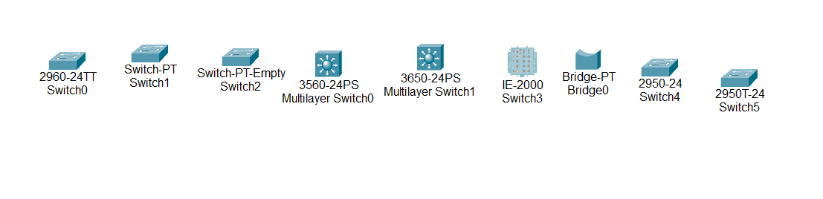

The switches shown in your Cisco Packet Tracer image are a mix of different types of Layer 2 and Layer 3 devices, each designed for specific network roles. Let me break down the purpose and use case of each:

1. **2960-24TT Switch0**:
   * **Type**: Layer 2 switch.
   * **Ports**: 24 Fast Ethernet and 2 Gigabit Ethernet uplinks.
   * **Use**: Best suited for access layer switching in a small or medium-sized network, handling traffic from end devices like computers and printers.
2. **Switch-PT Switch1**:
   * **Type**: Basic Layer 2 switch.
   * **Use**: Simple switching with limited configuration options, mostly used for educational purposes or basic network simulations.
3. **Switch-PT-Empty Switch2**:
   * **Type**: Empty chassis switch.
   * **Use**: Allows you to add different types of modules (Ethernet, fiber) manually to customize the switch. Useful for simulating modular switch setups in Packet Tracer.
4. **3560-24PS Multilayer Switch0**:
   * **Type**: Layer 3 switch (Multilayer).
   * **Ports**: 24 Fast Ethernet and 2 Gigabit Ethernet uplinks, with PoE (Power over Ethernet) capability.
   * **Use**: For small to medium-sized enterprise networks. Supports routing between VLANs, making it a good option for the distribution layer in networks where inter-VLAN routing is needed.
5. **3650-24PS Multilayer Switch1**:
   * **Type**: Advanced Layer 3 switch (Multilayer).
   * **Ports**: 24 Gigabit Ethernet and PoE support.
   * **Use**: Often used in the core or distribution layers of larger networks due to its enhanced capabilities for routing and scalability. Suitable for environments requiring high-performance inter-VLAN routing, QoS, and security features.
6. **IE-2000 Switch3**:
   * **Type**: Industrial Ethernet switch.
   * **Use**: Designed for rugged environments like factories or outdoor areas. It can handle harsh conditions such as extreme temperatures, vibrations, and dust. Use this when building networks for industrial control systems or IoT environments.
7. **Bridge-PT Bridge0**:
   * **Type**: Layer 2 bridge.
   * **Use**: Bridges are older technology used for connecting two different segments of a network at Layer 2. In modern networks, switches have mostly replaced bridges, but this can be used for specific learning or legacy simulations.
8. **2950-24 Switch4**:
   * **Type**: Layer 2 switch.
   * **Ports**: 24 Fast Ethernet.
   * **Use**: Very basic switch with limited configuration and VLAN support. Best for small network environments or simulations focusing on basic Layer 2 functions like MAC address learning and forwarding.
9. **2950T-24 Switch5**:
   * **Type**: Layer 2 switch.
   * **Ports**: Similar to the 2950-24 but with a few additional features (such as Gigabit uplink ports).
   * **Use**: Used in small networks where Fast Ethernet is the primary connection type, but Gigabit uplinks are needed for faster backbone connections.

**When to Use Each Switch:**

* **Basic Layer 2 switches (2960, 2950)** are good for access layers, connecting end-user devices (like PCs, printers) in smaller networks.
* **Multilayer switches (3560, 3650)** should be used in larger networks, particularly when you need both switching and routing capabilities (e.g., inter-VLAN routing).
* **Industrial switches (IE-2000)** are ideal for networks deployed in rugged environments such as factories or outdoor installations.
* **Empty chassis switches (Switch-PT-Empty)** are useful for modular flexibility in larger, more complex networks where you need customizable port types.
* **Bridge-PT** is mostly for legacy networks or educational simulations, as modern networks rarely use bridges anymore.

**Task 3:** What is the difference between all the connection wires, and when to use them (mentioned in cisco packet tracer).



Each connection type in Cisco Packet Tracer is designed for specific purposes and is used to connect different types of devices.

**1. Automatically Chose Connection Type**

* **Purpose**: Cisco Packet Tracer automatically chooses the correct cable type based on the two devices you are connecting.
* **When to Use**: If you're unsure which cable type to choose, this option can help. However, it's best to understand the underlying types so that you can choose cables manually for specific learning purposes.

**2. Console**

* **Purpose**: This cable connects a PC or laptop to the console port of a network device (like a switch or router).
* **Type**: Usually a **rollover** or **RJ-45 to DB-9** cable.
* **When to Use**: When you need to configure a device using terminal emulation software such as PuTTY or Tera Term, especially for initial device configuration or troubleshooting.

**3. Copper Straight-Through**

* **Purpose**: Standard Ethernet cable used to connect different devices.
* **Type**: **RJ-45** connectors, Cat5/Cat6 cables.
* **When to Use**: Use this to connect **different device types** (e.g., PC to switch, router to switch). It's the most common cable for regular Ethernet connections.

**4. Copper Cross-Over**

* **Purpose**: Used to connect similar devices directly.
* **Type**: **RJ-45** connectors, crossover wiring inside the cable.
* **When to Use**: Use to connect **similar device types** (e.g., PC to PC, switch to switch, or router to router). Modern devices support **Auto MDI/MDIX**, making cross-over cables less necessary, but it's good to know for legacy equipment.

**5. Fiber**

* **Purpose**: High-speed data transmission over longer distances using light signals.
* **Type**: **Fiber optic cables** with either single-mode or multi-mode fiber.
* **When to Use**: For connections requiring **high bandwidth** and long distances (e.g., between buildings or data centers). It connects devices with fiber interfaces like routers, switches, or firewalls.

**6. Phone**

* **Purpose**: Used for voice communication or telephone connectivity.
* **Type**: **RJ-11** connectors (similar to old telephone lines).
* **When to Use**: When simulating old-school analog telephony systems or connecting VoIP devices to an analog line in Cisco Packet Tracer.

**7. Coaxial**

* **Purpose**: Coaxial cables are typically used for cable TV, internet, or older networking technologies.
* **Type**: **Coaxial cables** (thick, shielded copper wire with an outer insulation layer).
* **When to Use**: Use for **legacy technologies** such as Ethernet over coax or when simulating older WAN technologies in Packet Tracer.

**8. Serial DCE (Data Communications Equipment)**

* **Purpose**: Used in WAN connections, often to connect routers via serial interfaces. **DCE** devices provide the clock rate.
* **Type**: **Serial cable** with V.35 connectors.
* **When to Use**: Use this cable to connect two routers in a **WAN simulation**. The DCE side of the connection provides clocking (you set the clock rate on this side).

**9. Serial DTE (Data Terminal Equipment)**

* **Purpose**: Also used in WAN connections but doesn't provide clocking.
* **Type**: **Serial cable** with V.35 connectors.
* **When to Use**: Use this cable to connect to the **DCE** side of a router when simulating a WAN connection. The DTE side doesn't provide the clock rate, so it depends on the DCE side for timing.

**10. Octal**

* **Purpose**: Special type of cable that connects multiple serial connections to a single device.
* **Type**: Octal cable with **8 serial connectors**.
* **When to Use**: Typically used in high-density configurations when managing multiple serial connections simultaneously (e.g., in **terminal servers**). This cable isn't commonly used in smaller network setups.

**11. IoT Custom Cable**

* **Purpose**: Special cable used for connecting **IoT devices** in Packet Tracer simulations.
* **When to Use**: This is for IoT simulations, particularly when linking custom IoT devices to the network for interaction between sensors, smart devices, and controllers.

**12. USB**

* **Purpose**: Standard USB cable used to connect devices such as a PC to a router or IoT devices.
* **When to Use**: Primarily used to simulate USB connectivity between end devices and network equipment (e.g., for configuration or data transfer purposes).